Taipei National University of the Arts Student Counseling Center
Informed Consent for Awareness of Individual Counseling Rights
- The personal information and interview data you provide to the TNUA Student Counseling Center will be used for counseling purposes only, and will be handled and stored in a "confidential" manner in accordance with the provisions of the Personal Information Protection Act. These will also be destroyed by the Center after ten years in accordance with the provisions of the law. You are free to choose how much personal information you want to share, but if you do not provide your personal information, you may not be able to complete the initial counseling process. Your personal as well as interview information will only be disclosed to the necessary parties with your consent.
- However, according to ethical guidelines, if you are endangering your own or others' life, freedom, or property; or if you have incurred legal liabilities (such as those governed by the Child/Youth Welfare Law, Genetic Health Act, Domestic Violence Prevention Law, Gender Equity Act, Education Act, etc.), we may be required to break confidentiality.
- Students (current) or faculty members who seek individual counseling at the Counseling Center should carefully review their rights and obligations:
  - Number of sessions: 50 minutes per session, once a week for several consecutive weeks; 8 sessions (including leave) for the first appointment, 6 sessions (including leave) for renewals; you have the right to terminate the counseling session at any time, but you must speak to the counselor before doing so.
  - Leave application process: Counseling uses an advance reservation system. If you are unable to attend your session for any reason, please contact the Center at least 24 hours in advance to reschedule or cancel (Center Tel: 02-2896-1000 ext. 1348). If you fail to submit a leave application or miss the session for a second time without a valid reason, the Center will cancel your pre-arranged session and you will need to make a new reservation.
  - Change of counselor: The Center will arrange a suitable counselor according to your schedule and needs. However, if you want to change your counselor during the counseling process, you must first discuss it with your current counselor and complete the case before a new arrangement can be made.
  - Free service: The Center provides free counseling services for its students (current) and faculty members, but there is a limit to the number of sessions you can receive.
  - Remote counseling: During the pandemic, if our school adopts remote teaching, counseling will be conducted via video to ensure continuity and effectiveness of counseling. Please refer to the following notes for video counseling:

    - Please present your student ID (or photo ID) to verify your identity and coordinate with your counselor to assess whether your location is suitable for the counseling session.
    - You need to be in a safe, isolated and soundproof environment. If the counselor assesses that your environment is not suitable for remote counseling, he/she may recommend suspension of the service.
  - Audio and Video Recording: During counseling sessions (both in person and remotely), both parties are prohibited from audio and video recording the session without the other party's informed consent, in accordance with the principles of respect and mutual trust. This is to protect the privacy of both parties. If audio or video recording is conducted without informing or obtaining consent, or if reminders or discouragement are ineffective, the Center may terminate the counseling service and take legal action to resolve any disputes that may arise.
_____________________________________________________________________________
I have read this informed consent carefully and have asked questions to clarify any parts that were unclear to me. I fully understand my personal rights and obligations, and I agree to abide by them.
Signature of Applicant：________________ Date:______________
Signature of Counselor：________________ Date：_____________
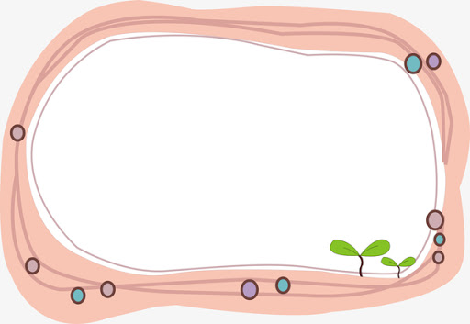
Mood Thermometer
Brief Symptom Rating Scale（BSRS-5）

Please rate how much each of the following has affected you in the past week (including today) by circling the number that best applies to you:
 | Not at All | Slightly | Moderately | Severely | Extremely
(1) Difficulty sleeping, e.g. difficulty falling asleep, waking up easily or too early | ０ | １ | ２ | ３ | ４
(2) Feeling nervous or anxious | ０ | １ | ２ | ３ | ４
(3) Feeling easily distressed or irritated | ０ | １ | ２ | ３ | ４
(4) Feeling depressed and down | ０ | １ | ２ | ３ | ４
(5) Feeling inferior to others | ０ | １ | ２ | ３ | ４
★Suicidal idea | ０ | １ | ２ | ３ | ４
Please fill in the scores:
Total from（1）-（5）： , ★Suicide idea:___________
～Courtesy of NTU, Prof. Li, Ming-Pin～

Description:
1. Total scores for questions (1) to (5):
- 0~5：Good physical and mental fitness
- 6~9：Slightly emotionally disturbed; talking to family members or friends to share one’s feelings and receive emotional support is advised.
- 10~14：Moderate emotional distress; seeking psychological counseling or receiving professional counseling is advised.
- ＞15：Severe emotional distress; high level of care is needed; referral for psychiatric treatment or professional counseling is recommended.
2.★ Score for "Suicide idea":
This is an additional item. If the total score for the previous 5 questions is less than 6, but the score for this item is 2 or more, psychiatric treatment is recommended.
~Warmest Regards from TNUA Counseling Center~

